ENVIRONMENTAL POLICY

Denso (Australia) Pty Ltd is committed to conducting its business in a manner that delivers leading environmental performance.
It is Denso’s policy to achieve a high standard of environmental care by complying with current legislation and seeking continuous improvement in performance by taking account of evolving scientific knowledge and community expectations.
Specifically, it is company policy to:
- Comply with all applicable laws, regulations and standards; uphold the spirit of the law; and where laws do not adequately protect the environment, apply standards that minimise any adverse environmental impacts resulting from its operations, products and services.
- Communicate with government and the community on environmental issues, and contribute to the development of policies, legislation and regulations that may affect Denso.
- Ensure that its employees and suppliers of goods and services are informed about this policy and aware of their environmental responsibilities in relation to Denso’s business.
- Ensure that it has management systems to identify, control and monitor environmental risks arising from its operations.
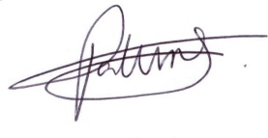
We comply with these policies by integrating them into our business planning, decision making, performance tracking and review processes to ensure we achieve our goals and continually improve upon them.

Paul Fortune
Managing Director
28/03/2022

